

Electronic Village Register Power Panel SoP

Abisai Ngalande

Table of Contents
1.0 Applicability 3
1.1 Users 3
2.0 Safety 3
2.1 Usage 3
2.2 Improper usage 3
3.0 Power Panel 3
3.1 Mounting 4
3.1.1 Step 1 4
3.1.2 Step 2 4
3.1.3 Step 3 4
4.0 Install the Low Voltage Disconnect 5
4.1 Low Voltage Disconnect (LVD) Parts 5
4.2 Low Voltage Disconnect (LVD) Part Identification 5
5.0 Setup 6
5.1 Set Dip Switch 6
5.2 LED indications 6
5.3 Connections 6
5.3.1 Step 1 7
Conclusion 7

1.0 Applicability
This manual describes the operation, function, and installation of the low voltage disconnect.

1.1 Users
These operating instructions are intended for technical personnel.

2.0 Safety

2.1 Usage
The low voltage disconnect should be used in a between the batteries and the load so that the battery life is prolonged.

2.2 Improper usage
Wrong connections may damage the unit. Reconnect voltage cannot be the same as disconnect voltage.

3.0 Power Panel
Power panel has all power related gadgets on for the desk.
It has:-
- Four DC/DC converters
- Solar charger
- ATA
- Interlock switch
- Reset switch
- Two cigarette lighter sockets
- PoE injector for radio
- Power-con female
- Speak-on male

3.1 Mounting
Hole are drilled in advance during the making the panel.

3.1.1 Step 1
  - Install the DC/DC converters starting with the 12V close to the cigarette lighter socket then the two the 19.5 V then 5V
  - Install solar charger at its place
  - Install the ATA
  - Install the reset switch and PoE injector.

3.1.2 Step 2
- Connect wires from 12V DC/DC converter to the cigarette socket with fuses in series with the positive terminals
- Connect two jacks to first 19.5V DC/DC to power J2 and printer
- Connect the second 19.5V DC/DC to the radio PoE injector
- Connect a jack to 5V DC/DC converter to power ATA.

3.1.3 Step 3
- Connect input cables of the DC/DC all in parallel with negative wire to negative terminal of load terminals of the solar charger.
- Connect positive wire to the reset button, connect the other terminal to interlock switch and then Connect the other terminal to the positive terminal of the solar charger.
- Connect Power-con to solar charge controller on panel terminals
- Install power cable with male speak-on on solar charge controller on battery terminal

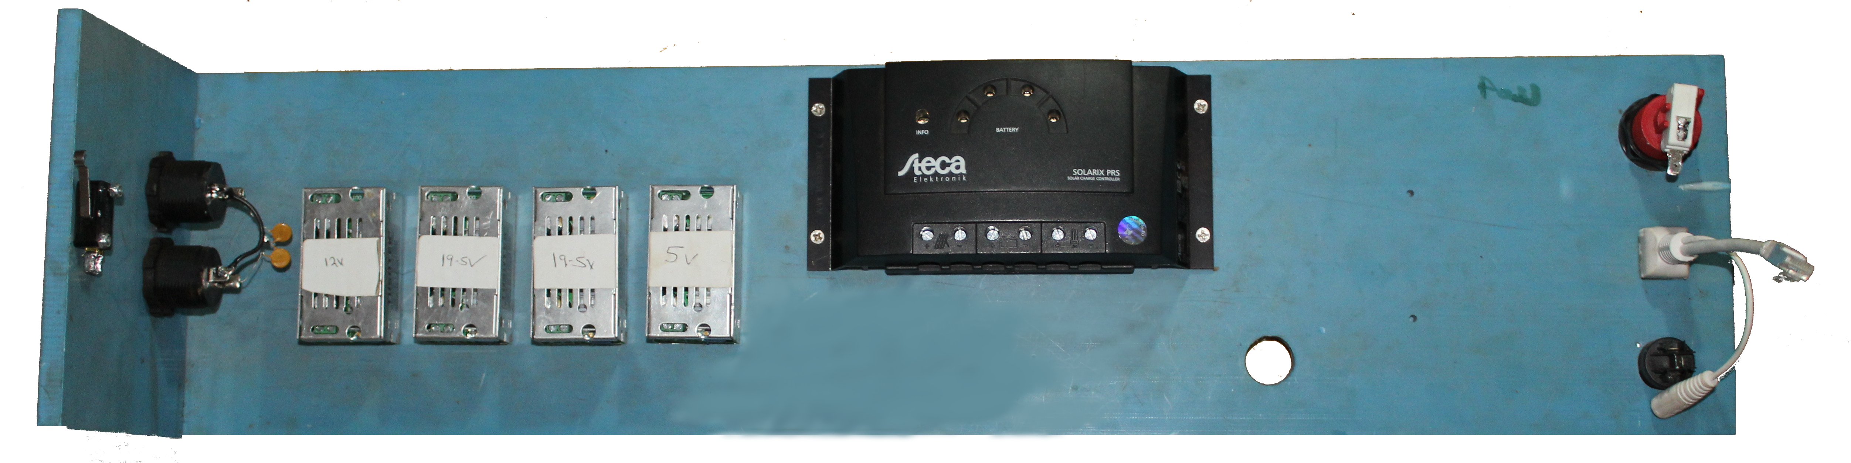

4.0 Install the Low Voltage Disconnect

4.1 Low Voltage Disconnect (LVD) Parts
- Contact relay
- Connector
  - Battery
  - Load
- Dip switches
- Dual color LED

4.2 Low Voltage Disconnect (LVD) Part Identification
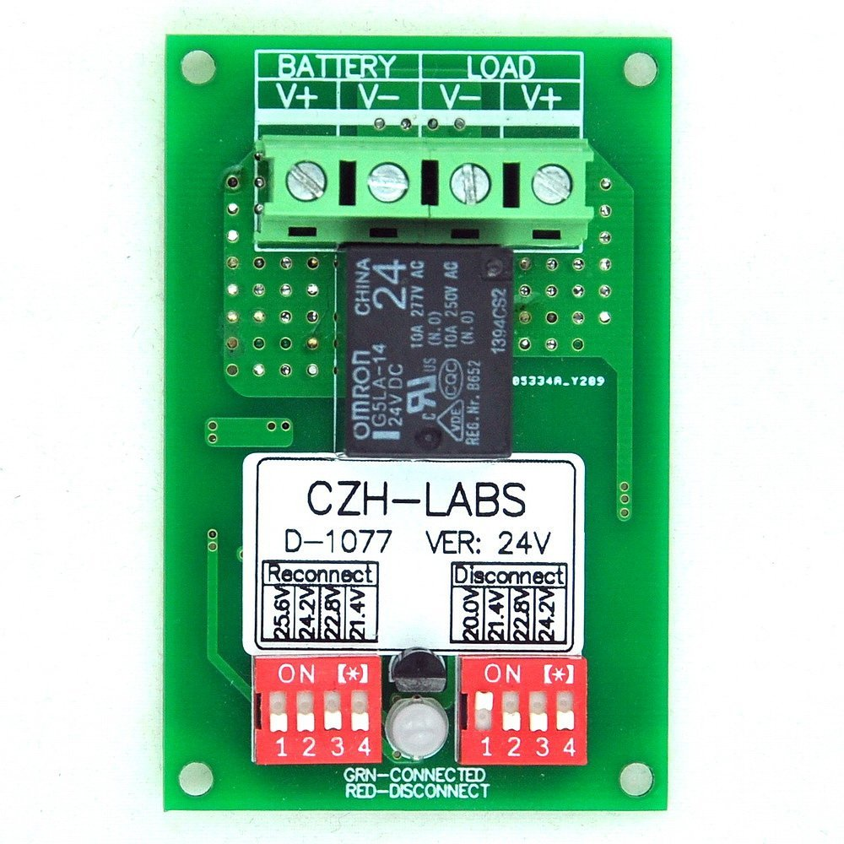

Load Terminals
Battery Terminals

Relay

Disconnect Dip Switch
Reconnect Dip Switch

5.0 Setup

5.1 Set Dip Switch
Turn on switch number two on the reconnect Dip switch side, this will set the reconnection voltage to 24.2V. Set disconnect side to 22.8V by turning on switch number three.

5.2 LED indications
LED light | Status | Meaning
Green LED | Working OK | Load is connected and using the batteries.
Red LED | Disconnected | Load has been disconnect

5.3 Connections
Connect V+ on battery side to positive side of the battery post of solar charger V- on battery side connector to negative side of the battery post of solar charger.
Connect Load terminals to the DC/DC converters.
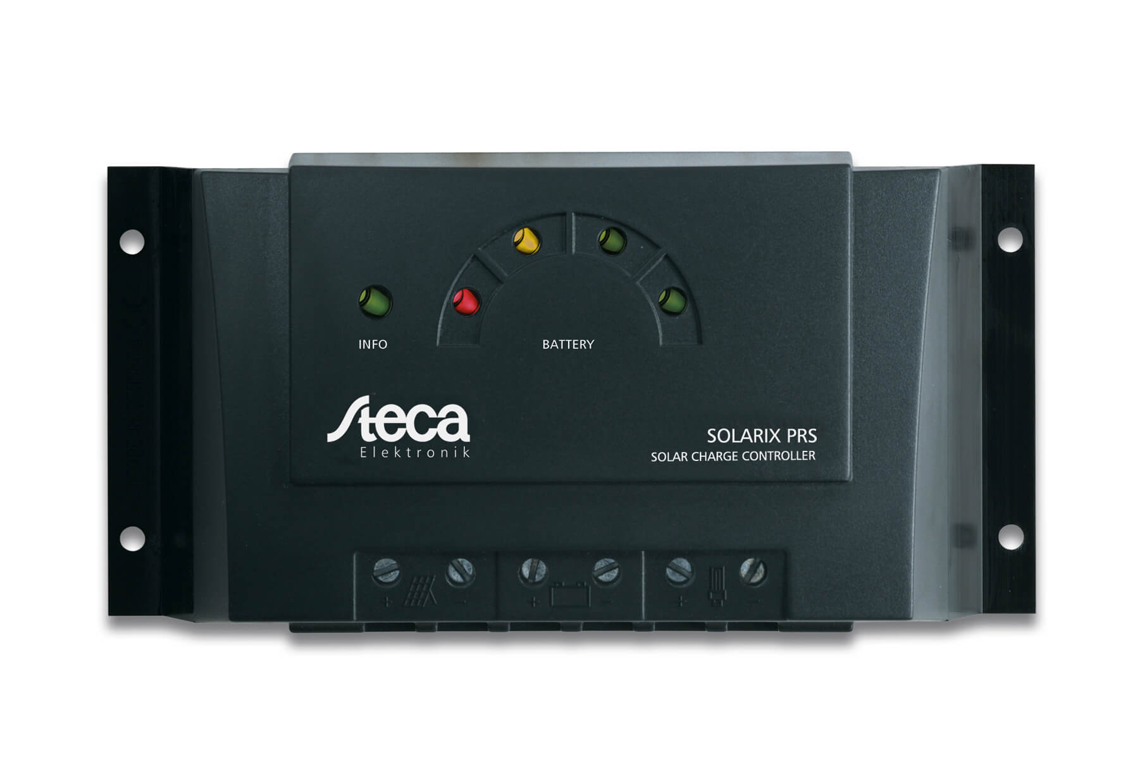

Solar Panel Connection
Speakon Connector To Battery
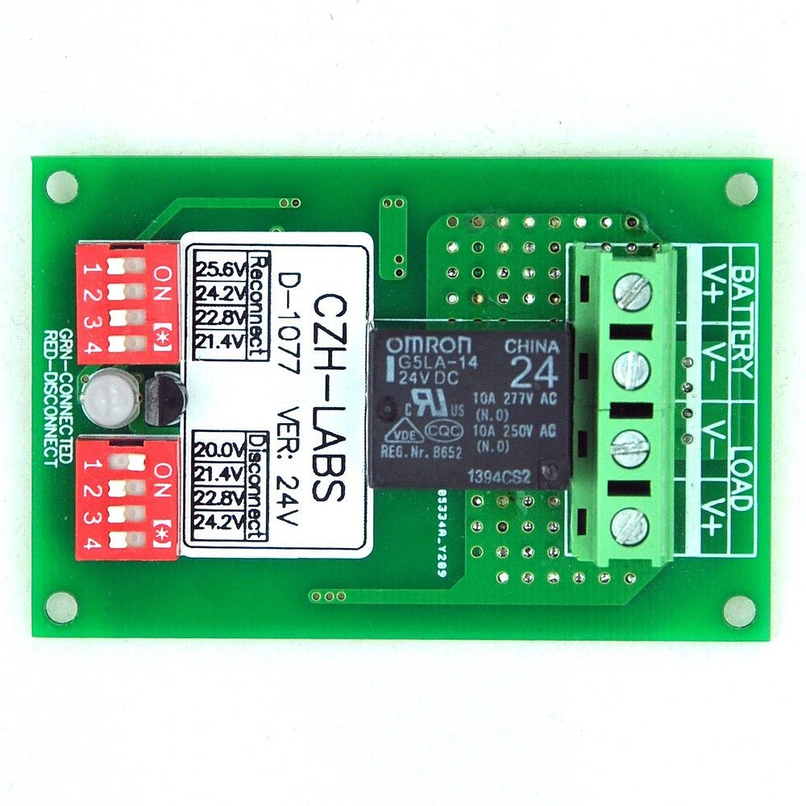

LOAD

5.3.1 Step 1
- Drill holes for mounting the LVD
- Install LVD connect the battery terminals to battery terminals on solar charger (Steca)
- Disconnect load terminal from solar charger(steca).
- Connect the load terminals to load terminals on LVD.
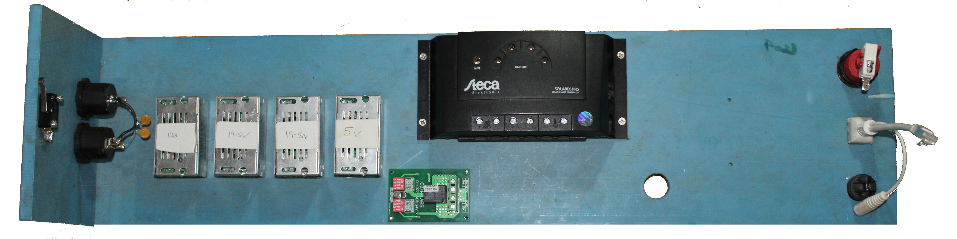

Conclusion
Check all the cables that they are well connected.
All DC/DC converter should be well label.
The setup will be running on a separate LVD.

